# **Power BI Data Analysis**

## **DAX and Calculated Columns**

### Initial Table Manipulation

For my Analysis of the GDP per Capita Growth dataset, I used two tables titled ‘each country metadata’, and ‘GDP per capita growth (annual %)’.

Using Power Query, I reorganised some columns and amended the datatypes in my dataset to make the data more useable. Firstly, I promoted the headers on both tables to make sure that all columns had the appropriate titles. In the GDP per capita growth table, I started by unpivoting the date columns, creating just one date column, and changed the datatype from Decimal Number to Date, and renamed it to Year.

### Data Model and Relationships

I created a bidirectional, Many-to-One relationship between these two tables using the Country Code column.

I also created a new table with columns for the Distinct Countries, Total Growth per country and also a Global Average Growth, with a One-to-Many relationship to the GDP per capita growth table, using the following formulas:

Total Growth = var curCountry = 'Country Total Growth'[Country Name] return CALCULATE(SUM('GDP per capita growth (annual %)'[GDP per Capita Growth %]), FILTER('GDP per capita growth (annual %)', curCountry = 'GDP per capita growth (annual %)'[Country Name]))

Global Average Growth = AVERAGE('Country Total Growth'[Total Growth])

### Decade Column

After reading and understanding the dataset, I began by creating a Decades column so that I could group the date data. To do this I used the following formula:

Decade = If(Year('GDP per capita growth (annual %)'[Year])<2000,"19" & Int((Year('GDP per capita growth (annual %)'[year])-1900)/10) & "0's", "20"& Int((Year('GDP per capita growth (annual %)'[Year])-2000)/10) & "0's")

Using these groupings I created a Decades slicer for each dashboard, so that the data can be filtered into decades for drilling down.

### HasRegion Column

Some elements of the data were missing, and there were country aggregation rows mixed in with the country data. This meant that some graphs would be skewed and country-by-country data would be inaccurate. I discovered that in the ‘each country metadata’ table, the Region column was empty for those aggregated rows. Using the following formula, I created a ‘HasRegion’ Boolean column, which I then used in my dashboard filtering to remove those aggregated entries:

HasRegion = IF(RELATED('each country metadata'[Region]) <> "", TRUE(), FALSE())

## **Analysis Dashboards**

### Top 5 Current Economic Powers Total GDP Growth since 1961

Initially, I wanted to look at the global top 5 Economic Powers ([www.investopedia.com](http://www.investopedia.com)), and compare their GDP growth:

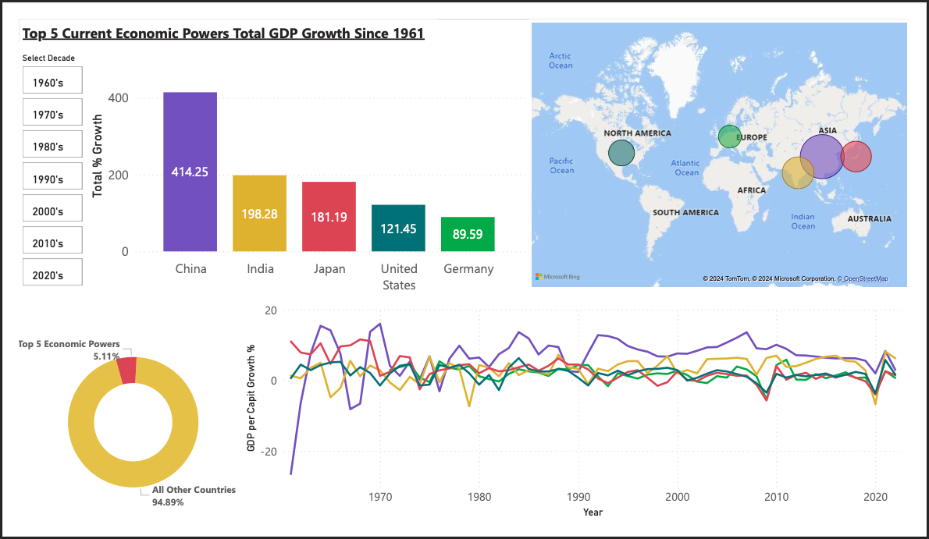

The bar chart shows us that since the 1960s, China has seen by far the most total growth, accumulating over 400% total growth. The geographic map gives a visual glance at those top 5 Powers. As seen on the line chart, China experienced a massive growth increase in the early 1960s, and has seen consistent growth since the 1980s.

Across all 5 powers, growth has been unsteady with peaks and troughs across the years. Notably, all of the countries saw a growth drop in 2009, with the US, Japan and Germany seeing a GDP negative growth of up to -5.5%. This correlates with the 2009 global financial crisis ‘Great Recession’ that marked general decline in almost all national economies globally.

We can also see a notable drop in 2020, following the global outbreak of COVID-19, known as the ‘Coronavirus Recession’.

## % GDP per Capita Growth by Income Group

The ‘each country metadata’ table has a ‘Income Group’ column, categorising each country into one of: High Income, Upper Middle Income, Lower Middle Income and Low Income. Using these groupings, I created the following dashboard to look at the growth differences across the various Income Groups:

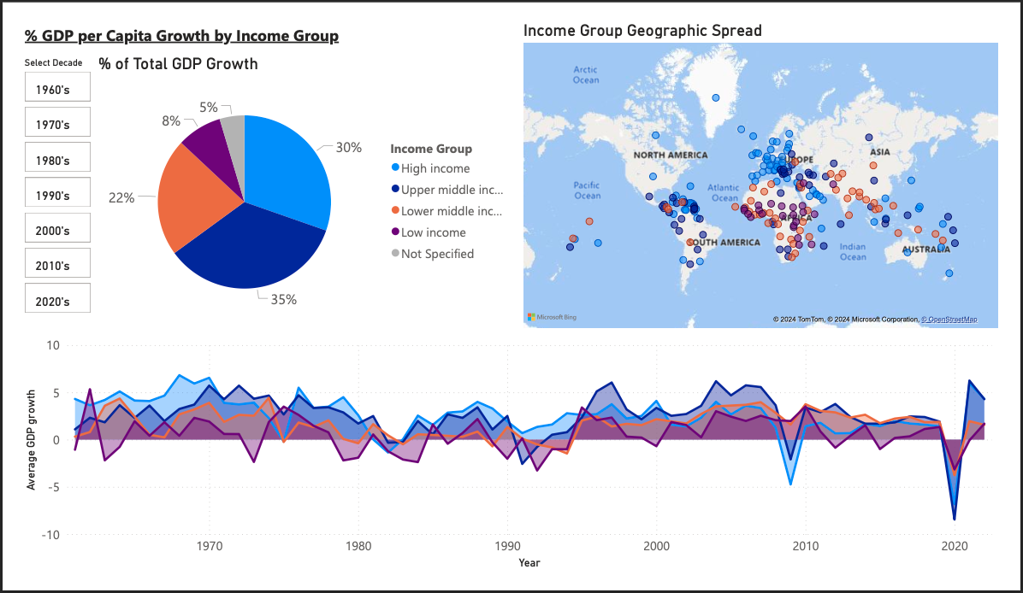

Of the total global % GDP growth, the Upper Middle Income and High Income groups have contributed the most, contributing 35% and 30% of all growth respectively. One would expect the High Income group to contribute the most, but globally there are more Upper Middle Income countries, so cumulatively they contribute more.

From the geographic map, we can see a concentration of High Income countries in Europe and the Middle East. There is also a concentration of Lower Middle and Low Income countries in Central and Eastern Africa, with more Lower Middle Income countries across Central Asia. Central America/The Caribbean has a variety of High, Upper and Lower Middle income countries.

The Line chart shows us that on average GDP growth over time has been unstable for all income groups, with the Low Income group countries seeing GDP decline several times since the 1960s. Similarly to the trend seen in the Top 5 Powers dashboard, all income groups saw decline in 2009 and 2020, although notably the Lower Middle and Low income groups did not experience negative growth in 2009, whereas the Upper Middle and High Income groups did.

## Top 5 vs Bottom 5 Countries by Total GDP Growth since 1961

For this dashboard I wanted to compare the Top and Bottom 5 countries by total growth. For this I used Top N and Bottom N filtering by Sum of GDP per capita growth.

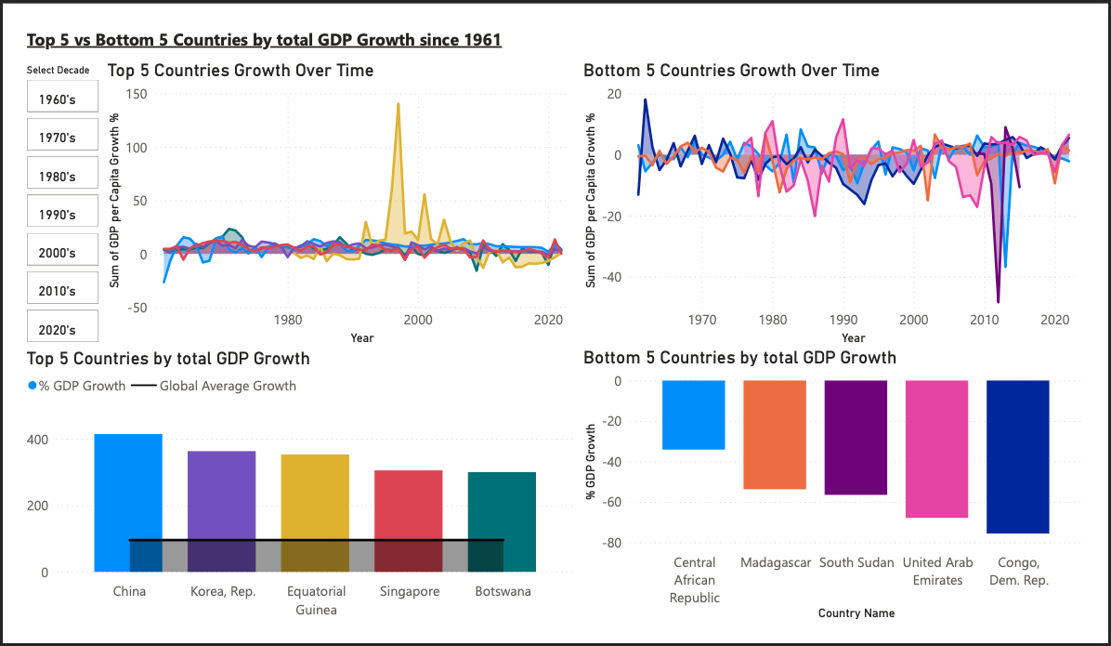

The Top 5 Countries by total growth are China, the Korean Republic, Equitorial Guinea, Singapore and Botswana, all seeing over 300% total GDP growth since the 1960s, compared to the the Global Average total growth (black line) at 96%.

The Bottom 5 Countries are Central African Republic, Madagascar, South Sudan, United Arab Emirates and the Congo Democratic Republic.

From the Line Charts showing growth over time, we can see that those Top 5 countries, saw more stable growth percetnages relative to the Bottom 5, although still quite unstable.

In 1997 Equitorial Guinea saw a huge spike in growth, netting a GDP growth of 140%. This was following a series of National Economic changes, including the discovery of Oil in the county in the early 1990s which caused a significant increase in the economy, a Presidential Election that took place in 1966, and a governmental initiative to attract more private sector investement in 1997.

In the early 2010s South Sudan and the Central African Republic saw singinificant negative growth spikes, pertaining to various governmental and economic factors: following a disputed election in South Sudan in 2010, a faction of the South Sudan Democratic Movement rebelled against the government causing national instability and ultimately economic decrease. Central African Republic saw national conflict in 2013, with fighting as part of the ongoing civil war.

The bottom 5 countries by growth have experienced a GDP decrease of, in total, between -34% (Central African Republic) and -76% (Democratic Republic of Congo).

## **GDP per Capita Growth by World Regions**

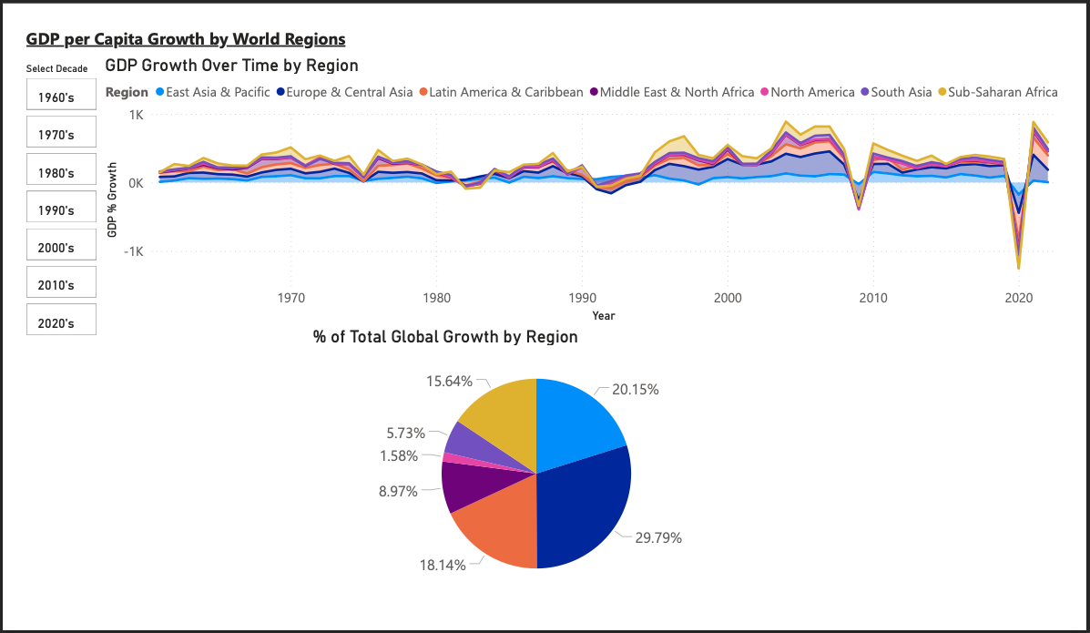This dashboard looks at the GDP growth, by Regions, as per the column included in the dataset.